ASSIGNMENT LAB 09

QUESTION NO 01 (CODE)

#include <iostream>

#include <string>

using namespace std ;

int main ()

{

string date;

cout<<"Enter the date like(date/month/year):\n";

cin>>date;

cout<<date[0]<<date[1]<<endl<<date[3]<<date[4]<<endl<<date[6]<<date[7]<<date[8]<<date[9];

return 0;

}

QUESTION NO 01 (OUTPUT)

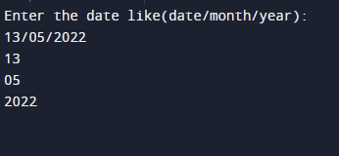

QUESTION NO 02 (CODE)

#include<iostream>

#include<string>

using namespace std;

int count(string x){

int y=x.length();

int z(0);

for(int i=0; i<y; i++)

{

if(x[i]==' '){

z=z+1;

}

}

cout<<"Number of words are:";

return z+1;

}

int main()

{

string word;

cout << "Enter any words:";

getline(cin,word);

cout<<count(word);

return 0;

}

QUESTION NO 02(OUTPUT)

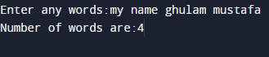

QUESTION NO 03 (CODE)

#include<iostream>

#include<string>

using namespace std;

int main()

{

string num1, num2;

cout << "Enter phone number:";

getline(cin,num1);

num2=num1.substr(0,4);

if(num2=="0300")

{

cout<<"Moblink!"<<endl;

}

else if(num2=="0333")

{

cout<<"Ufone!"<<endl;

}

else if(num2=="0315")

{

cout<<"Zong"<<endl;

}

else if(num2=="0345")

{

cout<<"Telenor"<<endl;

}

return 0;

}

QUESTION NO 03(OUTPUT)

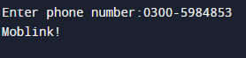



QUESTION NO 04 (CODE)

#include<iostream>

#include<iostream>

using namespace std;

int main()

{

string first_name,last_name;

cout << "Enter first name:";

cin>>first_name;

cout << "Enter last name:";

cin>>last_name;

cout<<first_name<<"."<<last_name<<"@iba-suk.edu.pk";

return 0;

}

QUESTION NO 04(OUTPUT)

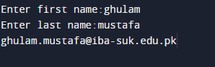

QUESTION NO 05 (CODE)

#include <iostream>

#include<string>

using namespace std;

string my_lower(string letters)

{

int len=letters.length();

for(int i=0; i<len; i++)

{

if(letters[i]>=65 && letters[i]<=90)

{

letters[i]=letters[i]+32;

}

}

return letters;

}

int main() {

string words;

cout << "Write any words:\n";

getline(cin,words);

cout<<my_lower(words);

return 0;

}

QUESTION NO 05(OUTPUT)

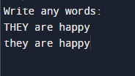

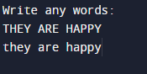

QUESTION NO 06 (CODE)

#include <iostream>

#include<string>

using namespace std;

string my_upper(string letters)

{

int len=letters.length();

for(int i=0; i<len; i++)

{

if(letters[i]>96 && letters[i]<123)

{

letters[i]=letters[i]-32;

}

}

return letters;

}

int main() {

string words;

cout << "Write any words:\n";

getline(cin,words);

cout<<my_upper(words);

return 0;

}

QUESTION NO 06(OUTPUT)

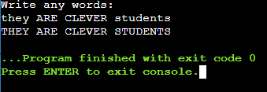

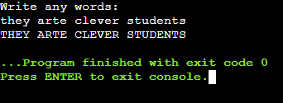

QUESTION NO 07(CODE)

#include<iostream>

#include<string>

using namespace std;

int main()

{

string word,reverse;

cout<<"Write any word:";

cin>>word;

int y=word.length();

for(int i=y-1, j=0; i>=0; i--, j++)

{

reverse[j]=word[i];

}

for(int i=0; i<y; i++)

{

if(word[i]==reverse[i])

{

cout<<"Word is palindrome!"<<endl;

break;

}

else if(word[i]!=reverse[i])

{

cout<<"Word is not palindrome!"<<endl;

break;

}

}

return 0;

}

QUESTION NO 07(OUTPUT)

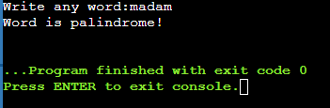

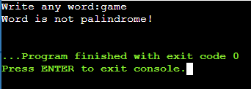

QUESTION NO 08(CODE)

#include <iostream>

#include <string>

using namespace std;

int main()

{

int x(0),y(0),z(0);

string words,search;

cout << "Write some words:"<<endl;

getline(cin,words);

int len=words.length();

cout<<"What word do you want to find:"<<endl;

cin>>search;

for(int i=0; i<len; i++){

if(words[i]==' ')

{

z=z+1;

}

}

for(int i=0; i<z; i++)

{

x=words.find(search,y);

if(x==string::npos)

break;

y=x+1;

cout<<x<<" ";

}

return 0;

}

QUESTION NO 08(OUTPUT)

